# GPU Shaders

Perform 1 at a time, quite slow when there is hundred million vertices

Can process concurrently, why gpu can achieve parallel processing because vertices does not share data

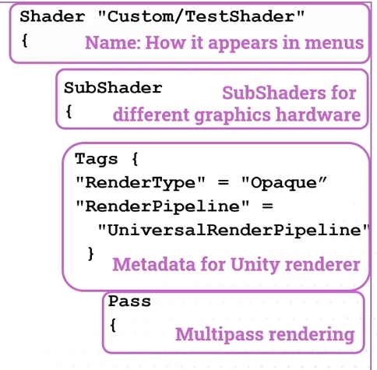

OS => Object Space

HCS => Canvas Space

MVP => Model View Projection which simplify the prev ss 3 line and more efficient

Always use this as it transform homolytic space to camera space

Make the object have wobbly effect

half4=>Half the size of float, the 4 is rgba

half4 _BaseColour; => uniform variable

Flashing shader

Builtin function in Time, Time.y is the straightforward value

Rescale the value in intensity to 0 and 1 because sin will return -1 and 1

Stripe

Use abs because position of object space can be negative so it will always be below 1.0 so using abs will make the value to be always positive

